26. Prolog Program to Implement Monkey Banana Problem
Name:P.Gayathri
Reg.No:192424324

Aim
To write and execute a Prolog program to solve the Monkey Banana Problem by representing the positions of the monkey, box, and banana and finding a sequence of actions to obtain the banana.
Algorithm
- Start the program.
- Represent the initial state of the monkey, box, and banana.
- Define the possible actions:
  - Monkey can walk.
  - Monkey can push the box.
  - Monkey can climb onto the box.
  - Monkey can grab the banana.
- Check whether the monkey is at the same position as the box before pushing.
- Move the box below the banana.
- Allow the monkey to climb onto the box.
- If the monkey is on the box below the banana, allow it to grab the banana.
- Use recursion to find the sequence of actions.
- Display the sequence of actions.
- Stop the program.

PROGRAM:
% Monkey Banana Problem

% Initial State:
% Monkey is at left, Box is at middle,
% Banana is at right.

initial_state(state(left, middle, down, no)).

% Goal State:
% Monkey has got the banana.

goal(state(_, _, _, yes)).

% Monkey can walk from one position to another
move(state(Monkey, Box, down, No),
walk(Monkey, NewPosition),
state(NewPosition, Box, down, No)) :-
Monkey \= Box,
position(NewPosition),
NewPosition \= Monkey.

% Monkey pushes the box
move(state(Pos, Pos, down, No),
push(Pos, NewPosition),
state(NewPosition, NewPosition, down, No)) :-
position(NewPosition),
NewPosition \= Pos.

% Monkey climbs onto the box
move(state(Pos, Pos, down, No),
climb,
state(Pos, Pos, up, No)).

% Monkey grabs the banana
move(state(Pos, Pos, up, no),
grab,
state(Pos, Pos, up, yes)) :-
Pos = right.

% Possible positions
position(left).
position(middle).
position(right).

% Solve the problem
solve(Plan) :-
initial_state(Start),
search(Start, [Start], Plan).

% Goal reached
search(State, _, []) :-
goal(State).

% Search for a solution
search(State, Visited, [Action|Rest]) :-
move(State, Action, NextState),
\+ member(NextState, Visited),
search(NextState, [NextState|Visited], Rest).
INPUT:
?- solve(Plan).
OUTPUT:
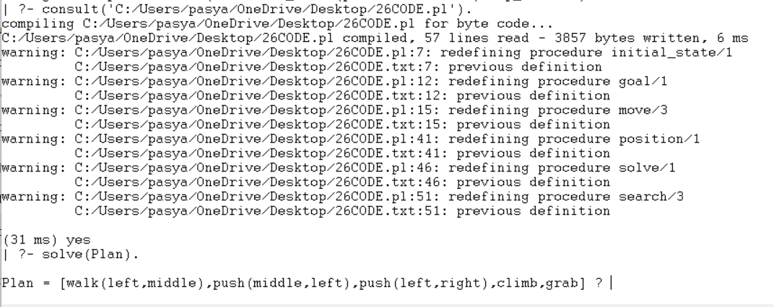

RESULT:
Thus, the Monkey Banana Problem was successfully implemented in Prolog, and the sequence of actions walk → push → climb → grab was obtained successfully to get the banana.

